Arduino Sensor Shield V5.0 Sensor expansion board
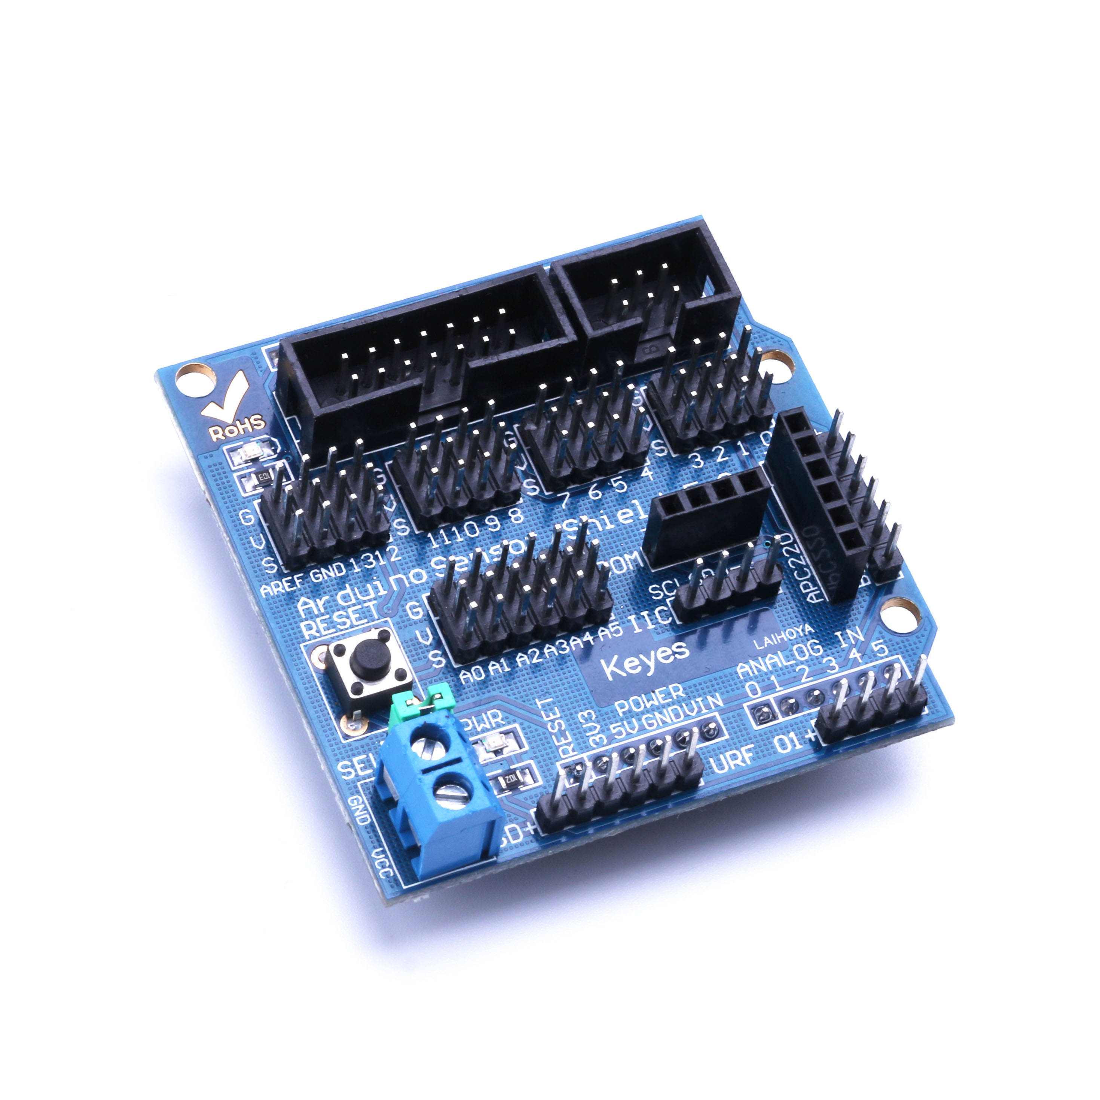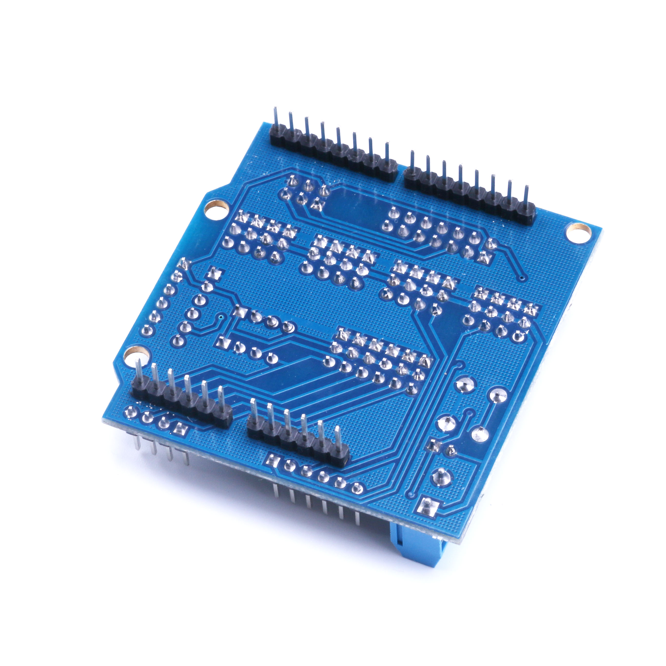
2010 latest Arduino sensor shield V5.0 sensor expansion board in retaining V4.0 merit based, still use stacked design, PCB heavy gold processing, the mother board will not only Arduino duemilanove 2009 controller of the digital and analog interface form of servo line order extended out, also ad hoc IIC interface, 32 steering gear controller interface, Bluetooth communication interface module, SD card communication interface module, apc220 wireless RF communication interface module, Rb URF v1.1 ultrasonic sensor interface, LCD serial and parallel interface, independent expanding out more easy to use convenient. For beginners of Arduino, without the need for complex circuit connection and a headache, the expansion of this sensor in the true sense circuit simplification, can easily be sensors are commonly used to connect, a sensor only need a general 3P sensor connection line is not divided into digital connecting line and simulates the connection line), to complete the circuit connection, write corresponding Arduino program downloaded to the Arduino duemilanove controller reads sensor data, or to receive the wireless module return data, through processing, ultimately easily completed your mutual action.
